**zID: z5143964**

**Name: PeiGuo Guan**

**Answer:**

In order to clearly understand the whole architecture, I list the key point of the whole functions and processes here:

HM: Home mobile network

RM: Roaming mobile network

**Conventional:**

1. Service provider(HM) makes roaming agreement with another network service provider(RM) if the provider(HM) cannot cover a particular city or country.
2. CDR is generated based on usage data from switch center. (CDR: Information like date, times, caller, callee, state, code, rate)
3. Rated CDRs sent to HM and charges based on predefined service. HM and RM partners settle financials monthly based on CDRs reports.
4. Clearinghouse works as an interface between different RM partners to help them exchange CDRs based on agreements. Clearinghouse receives billing record.
5. TAP, RAP

**Q1:**

The blockchain-based method to replace or augment the “Clearing House”:

**Public blockchain:** A public block chain is a permissionless blcokchain, anyone can join the network which means anyone can read and write.

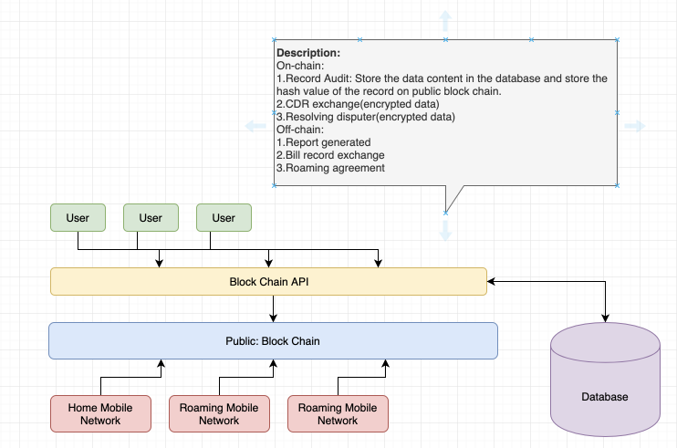

**Description Details:**

The record process of users’ information should not be on chain, since anyone can read and write it. Although the encrypted data may help to protect the confidentiality, the performance of it will very bad. If we use off chain to storage data, it will cost a lot. So using conventional way is better. By using hash value to generate report and put it on off-chain and exchange between different network.

The bill record exchange can use off-chain, since the way of the transaction is more security and it won’t public broadcast to the public. In case of on-chain transactions, it is possible to partially derive a participant’s identity by studying transaction patterns.

Roaming agreement setup in off-chain, since transfer agreements between 2 parties and it is authorized by third party guarantor.

If the CDR data size is huge, we can use conventional way to exchange data, but this cannot make sure the immutability of data. And if the data size is small, we can think of using on-chain by encrypting the detail of data, decrypted by the private key so as to guarantee the data immutability, integrity and confidentiality.

Since it is public block chain, resolving dispute is the issue between the providers, it can use off-chain to solve the dispute it is security and have more confidentiality.

**Private blockchain:** A private block chain is a permissioned block chain. In this case, only the home mobile network and the roaming mobile network which the customers currently in are permissioned.

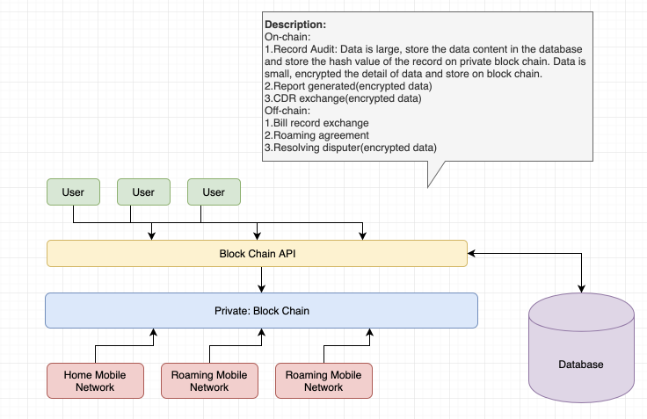

**Description Details:**

The private block provides more security and confidentiality.

If the data is not that big than we can use on-chain block chain with encrypted the detail like customer list and total number to store the data, since the data should be immutable and confidential and in private block, only the permitted network can join the block chain. Using hash value to generate report of users’ information, we can use report generated link number to locate the complete information, so we can put the report number on-chain with encrypted data, only the one who has private key has right to read and write the data.

The bill record exchange can use off-chain based on the CDR information, since the way of the transaction is confidential and the bill is between two parties.

Roaming agreement setup in off-chain, since transfer agreements between 2 parties and it is authorized by third party guarantor.

If the CDR data size is huge, we can use conventional way to exchange data, but if the data size is small, we can think of using on-chain by encrypting detail data, so as to guarantee the data immutability, integrity and confidentiality.

Since it is in private block chain, resolving dispute is the issue between the providers, it can use on-chain block chain to solve the dispute, and only the participants have right to read it so that the history can be recorded and approved.

**Q2:**

**Public Block Chain Scenario:**

1.

|  |  |
| --- | --- |
| Name | The confidentiality of users’ information |
| Description | Commercial confidentiality for telecommunication companies |
| Attribute | Confidentiality |
| Environment | Normal Operation |
| Stimulus | Other Network node in public block chain wants to read and write the data |
| Response | They have not right to change the data |
| Reason | The data is encrypted and the one who has private key has right to decrypted the data and get the hash value to locate the data. |

2.

|  |  |
| --- | --- |
| Name | Limitation of data shared |
| Description | Commercial confidentiality for telecommunication companies |
| Attribute | Privacy |
| Environment | Normal Operation |
| Stimulus | The roaming network tries to get the complete information of customer lists |
| Response | The data is unavailable for those roaming network service |
| Reason | The data shared to the other network is the least, and some of the important data like customer lists are encrypted. |

3.

|  |  |
| --- | --- |
| Name | Overload data response |
| Description | Throughput for accounting reconciliation |
| Attribute | Performance |
| Environment | High load |
| Stimulus | Lots of customers roaming and request in the same time |
| Response | System has a load balancer to deal with concurrent processing. |
| Reason | The data is stored in database in a conventional way, and the encrypted index URL is generated in block chain. |

4.

|  |  |
| --- | --- |
| Name | Integrity for accounting reconciliation |
| Description | Transactions only for those by authorized network. |
| Attribute | Integrity |
| Environment | Normal operation. |
| Stimulus | Some node tries to join and change data |
| Response | The node can join the chain successfully, but it is unavailable to change the data. |
| Reason | The data has been encrypted, and the hash value can check the content has been changed or not. |

5.

|  |  |
| --- | --- |
| Name | Latency response |
| Description | System builds up agreement within 250ms after user send the request |
| Attribute | Performance |
| Environment | Normal operations |
| Stimulus | Lots of Customers using the phone call in different country. |
| Response | Systems process the request and build up the agreement with other network service. |
| Reason | Different Network builds agreements in off-chain which is fast and security. |

6.

|  |  |
| --- | --- |
| Name | Information confidentiality. |
| Description | It is possible to partially derive a participant’s identity by studying transaction patterns. |
| Attribute | Confidentiality |
| Environment | Normal operation |
| Stimulus | Some node is studying transaction patterns to derive a participant’s identity |
| Response | Failure |
| Reason | The information is encrypted and only the one who has private key can get access to the data, and the off-chain data is more security. |

**Private Block Chain Scenario:**

1.

|  |  |
| --- | --- |
| Name | The confidentiality of users’ information |
| Description | Commercial confidentiality for telecommunication companies |
| Attribute | Confidentiality |
| Environment | Normal Operation |
| Stimulus | Other Network node in block chain wants to read and write the data |
| Response | They are not access to the private |
| Reason | The private block chain is permissionless, only the one who gets involved in the private chain has chance to read and write the data. |

2.

|  |  |
| --- | --- |
| Name | Limitation of data shared |
| Description | Commercial confidentiality for telecommunication companies |
| Attribute | Privacy |
| Environment | Normal Operation |
| Stimulus | The roaming network tries to get the complete information of customer lists |
| Response | The data is unavailable for those roaming network service |
| Reason | Same as the public chain, the data shared to the other network is the least, and some of the important data like customer lists are encrypted. |

3.

|  |  |
| --- | --- |
| Name | Overload data response |
| Description | Throughput for accounting reconciliation |
| Attribute | Performance |
| Environment | High load |
| Stimulus | Lots of customers roaming and request in the same time |
| Response | System has a load balancer to deal with concurrent processing. |
| Reason | The data is stored in database in a conventional way, and the encrypted index URL is generated in block chain on chain. |

4.

|  |  |
| --- | --- |
| Name | Integrity for accounting reconciliation |
| Description | Transactions only for those by authorized network. |
| Attribute | Integrity |
| Environment | Normal operation. |
| Stimulus | Some node tries to join and change data |
| Response | The node cannot join the chain. |
| Reason | It is private block chain and the data has been encrypted. The hash value can check the content integrity. |

5.

|  |  |
| --- | --- |
| Name | Latency response |
| Description | System builds up agreement within 250ms after user send the request |
| Attribute | Performance |
| Environment | Normal operations |
| Stimulus | Lots of Customers using the phone call in different country. |
| Response | Systems process the request and build up the agreement with other network service. |
| Reason | Different Network builds agreement in off-chain which is fast and security. |

6.

|  |  |
| --- | --- |
| Name | Information confidentiality. |
| Description | It is possible to partially derive a participant’s identity by studying transaction patterns. |
| Attribute | Confidentiality |
| Environment | Normal operation |
| Stimulus | Some node is studying transaction patterns to derive a participant’s identity |
| Response | Failure |
| Reason | In private block chain, the participants are all authorized by third party and the information is encrypted and only the one who has private key can get access to the data, and the off-chain data is more security. |

**Q3:**

In my opinion, using private block chain is better, since the home mobile network and roaming mobile network is like partners and some of the transactions and agreement would be more security by using private block chain. Compared with public block chain, lots it has permissionless mechanism, so when the data broadcast to the public, the one without authorized or certification cannot read and write, it guarantees the security, confidentiality and privacy. It also saves the bits size to some degree without encryption. Most importantly, it saves the property of block chain like immutability, safety, and so on compared with conventional way.

However, all of this assumption is based on the data size is not large. If we need to transfer and process big data, conventional way is better, since the performance of the block chain is pretty bad like the latency, throughput, the cost and son on.